Name:Ganta Srivani

Enrollno:2403A54123

Batch:(DS)batch-04

# Task 0

* Install and configure GitHub Copilot in VS Code. Take screenshots of each step.

Expected Output

* Install and configure GitHub Copilot in VS Code. Take screenshots of each step.

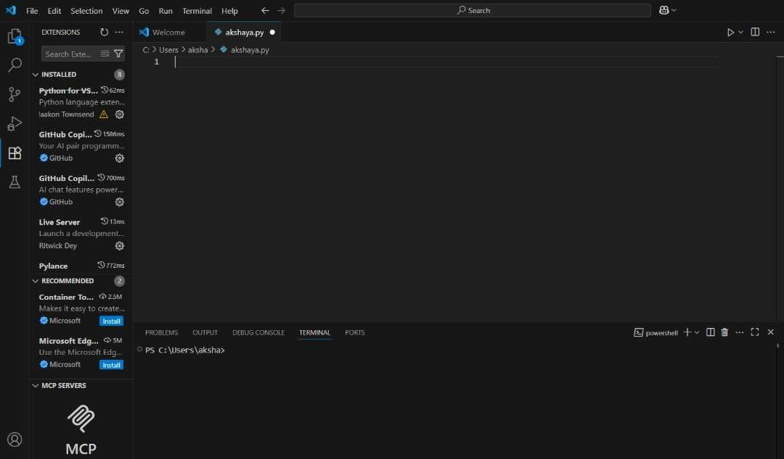

Task 1: Factorial without Functions

* Description:

Use GitHub Copilot to generate a Python program that calculates the factorial of a number without defining any functions (using loops directly in the main code).

* Expected Output:
  + A working program that correctly calculates the factorial for userprovided input.
  + Screenshots of the code generation process.

prompt : generate a python program which takes a number from the user and give the factorial as the output ,without using any functions

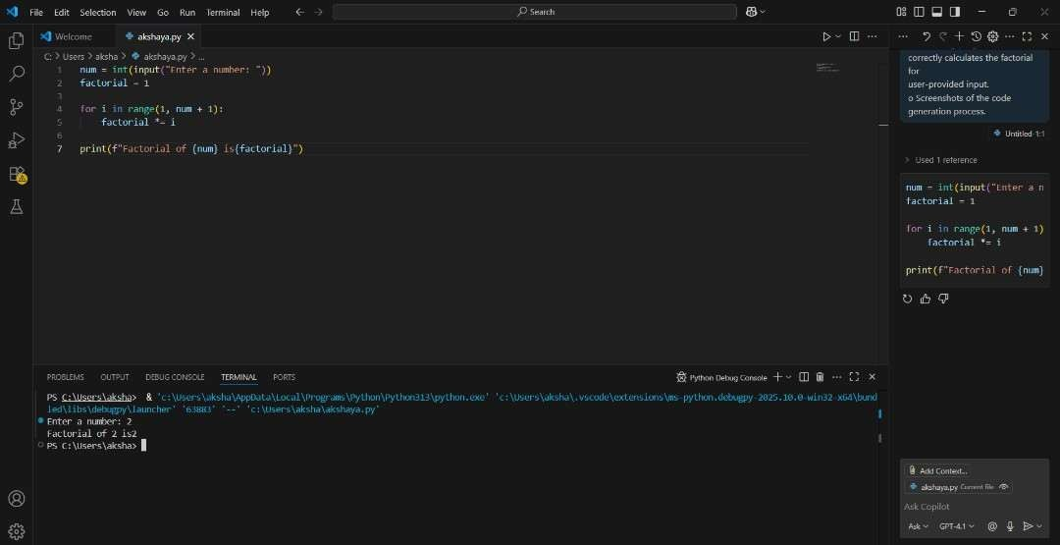

Task 2: Improving Efficiency ● Description:

Examine the Copilot-generated code from Task 1 and demonstrate how its efficiency can be improved (e.g., removing unnecessary variables, optimizing loops).

* Expected Output:
  + Original and improved versions of the code.
  + Explanation of how the improvements enhance performance.

prompt : improve the efficiency from the previous code by removing unnecessary variables,optimizing loops etc…

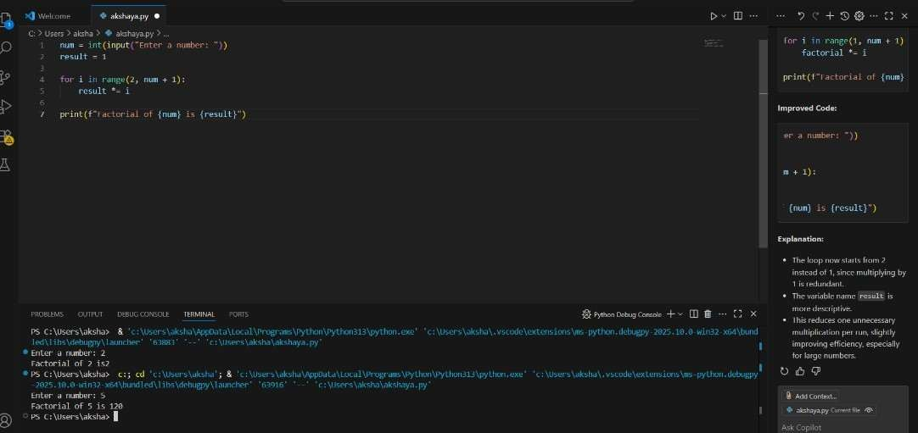

Task 3:Factorial with Functions ● Description:

Use GitHub Copilot to generate a Python program that calculates the factorial of a number using a user-defined function.

* Expected Output:
  + Correctly working factorial function with sample outputs.
  + Documentation of the steps Copilot followed to generate the function. Prompt :generate a python program which take the input from the user and give factorial of it by taking an user defined function

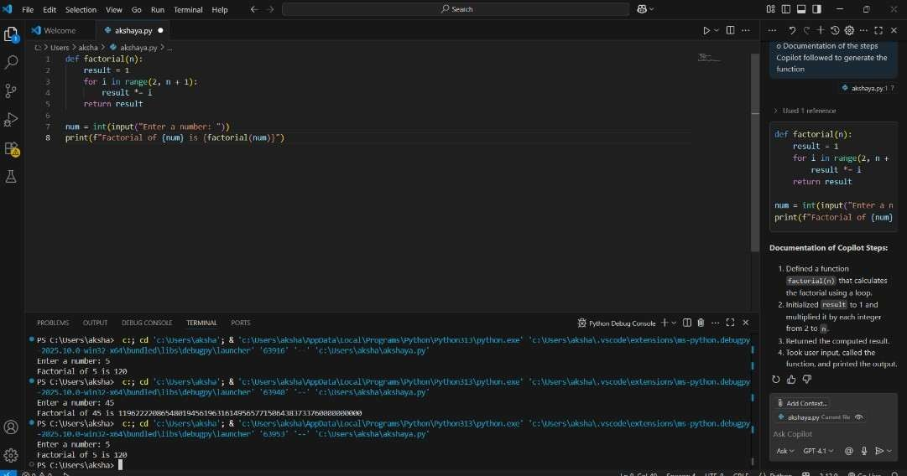

Task 4: Comparative Analysis – With vs Without Functions

* Description:

Differentiate between the Copilot-generated factorial program with functions and without functions in terms of logic, reusability, and execution.

* Expected Output:

A comparison table or short report explaining the differences Prompt:

* Differentiate between program with functions and without functions in terms of logic, reusability, and execution.

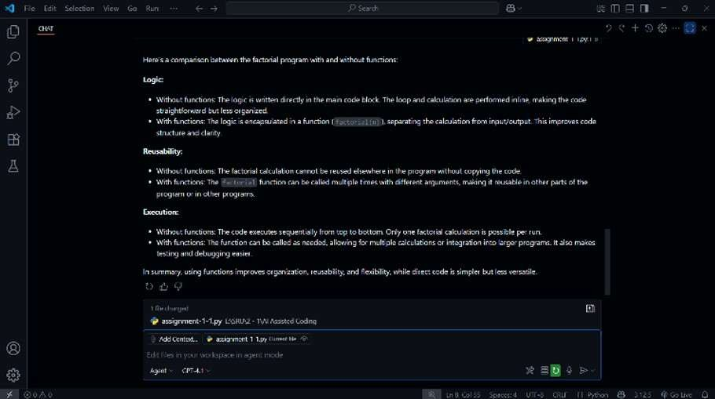

Task 5: Iterative vs Recursive Factorial

* Description:

Prompt GitHub Copilot to generate both iterative and recursive versions of the factorial function.

* Expected Output:

o Two correct implementations. o A documented comparison of logic, performance, and execution flow between iterative and recursive approaches.

* Prompt : generate both iterative and recursive versions of the factorial function

